Final Exam Process: Summer 2021

Review Current Final Exam Information
Each scheduler received a spreadsheet showing all active course offerings for the term. The final exam indicator is in column H.
This information is based on the non-combined scheduling guidelines shown below.
Summer II 2021 Non Combined Scheduling Guidelines
If the class begins  at the hour listed and meets  a.) four, five, or six days a week; or  b.) MWF or any two of those days; or  c.) TThS or any two of those days: | The exam is given at:
7 or 7:30am | 7:00 pm, Friday, August 6
8 or 8:30am | 8:00 am, Saturday, August 7
9 or 9:30am | 1:00 pm, Friday, August 6
10 or 10:30am | 8:00 am, Friday, August 6
11 or 11:30am | 1:00 pm, Saturday, August 7
12 or 12:30pm | Arranged – Date/Time to be determined by instructor
1 or 1:30pm | 10:30 am, Saturday, August 7
2 or 2:30pm | 3:30 pm, Friday, August 6
3 or 3:30pm | 10:30 am, Friday, August 6
4 or 4:30pm | 3:30 pm, Saturday, August 7
5pm or later | 7:00 pm, Friday, August 6
Online without set meeting time | Arranged – Date/Time to be determined by instructor

Sections that meet both of the requirements below are eligible for an automatic exam assignment:

1. Course must have a meeting time in Banner at 7am or later.
2. Course must have an assigned classroom.
Sections that currently have the 1F indicator will show their automatically assigned final exam information in Columns S-V.
Sections that are not eligible for automatic assignment include:
1. The course does not have an assigned room or time.
2. The course is an online course.
3. The course starts at 12 or 12:30.

Sections with the 1F indicator list “Arranged” in Column S.
Confirm Exams and Final Exam Indicator
Verify with your instructors that the 1F is marked correctly for all sections (either marked or left blank).
If you need to make changes to the 1F indicator, please do so in Banner. This spreadsheet is for reference only.
If the section will have a final exam and at the fixed time in accordance with the published schedule (found here), make sure those sections have the 1F indicated in Banner (under the automatic scheduler field in the meeting row).
If the instructor is either offering the student a window to take the exam (longer than 2 hours, or over the span of multiple days, for example) or not giving a final exam at all, remove the 1F indicator (automatic scheduler field is blank). Our office does not need to know about these situations. Course Explorer will refer students to contact the instructor for exam details.
Any changes made in Banner need to be made to all crosslisted sections as well since final exam listings are shown on the Course Explorer website under their specific course listing. If the changes are not made in Banner, they will not be reflected when we run our process to assign the automatically scheduled exams to their locations.

Marking a Course in Banner
To mark a course in Banner, open the SSASECT form and type in the term and CRN of the section you need to modify. Go to the “Meeting Types and Instructor Tab” and then the “Meeting Location and Credits” sub-tab. Enter 1F in the Automatic Scheduler Field.
If the section is cross-listed, make sure there is an “O” in the Override Indicator or you will get a “room conflict” error when you save the record.
Note: If a linked course has a component where all the students meet together, only the CRN representing that "all-inclusive" meeting should have the 1F and not the breakout components.
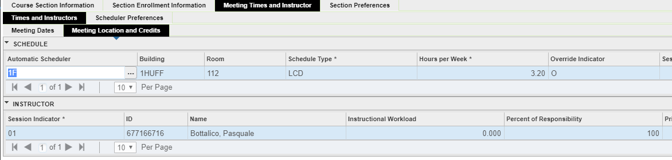

Additional Considerations for Summer
If you want a fixed time for a final for sections that meet simultaneously, make sure both sections have the 1F in Banner.

If you want a fixed time for a final and the online section is asynchronous, you will need to email fms-reserve@illinois.edu to have that section's exam listed with the same exam day/time as the in-person.

For both situations above, exams will be considered non-combined and not arranged.

Exams for fully online classes must be online.

In Person Exam Information

If an instructor wants to give a non-combined exam in person for a class with an in person component, enter the 1F in Banner and REQUEST an in-person exam by completing columns W and X on the spreadsheet. For sections using distributed attendance, indicate the total number of students who would need to be accommodated in column X. Spreadsheets with in-person exam requests need to be sent to fms-reserve@illinois.edu by 5pm on Wednesday June 23, 2021.

Note – Do NOT return the spreadsheet unless you have in person courses that are requesting an in person final exam. Exams by default will be assumed to be online unless they qualify to be indicated otherwise.

Special Requests
Special requests for exams can be sent now via email. There will be a second spreadsheet of automatically scheduled exams, but special requests will not go on that sheet. We have simplified the process to a single step.
Arranged exams will not be displayed on any final exam web listing unless we have a fixed day and time for the exam. Accordingly, send exam information (day and time) to fms-reserve@illinois.edu by 5:00 PM on Wednesday June 23, 2021.
For in-person exam requests other than non-combined, email those to us; do not list on the spreadsheet. We will accommodate what we are able to, but non-combined exams will be first priority.
Summer II 2021 Processing Calendar
Date | Process
Wed., June 23 | All 1Fs need to be added or removed in Banner and all special requests (Combined, Conflict, Arranged) due by 5pm.
Thu., July 1 | Final exam schedule is posted to Course Explorer for the entire campus community and myillini for students.

All questions and inquiries with regard to this procedure or with general final exam policy can be made via email to fms-reserve@illinois.edu or by calling 217.333.1230. Due to the nature of some phone questions, you may be asked to email information for documentation purposes.

