Dear Schedulers,
As you may know, we have a process for setting up CRNs when sections do not meet according to standard part of term dates (i.e. full term, 1st or 2nd 8 weeks). Schedulers set up these sections as “XM-OL” which is an old term/Banner code that we are using today to mean “non-standard” with regard to duration. (We also use the term “non-standard” that relates to teaching “times.”)
If you are new to setting up sections that are non-standard duration, there are a few differences from regular section set-up.
Leaving non-standard sections in a standard part of term can allow add/drop/refund deadlines that are more generous, or more restrictive, than should be according to the Student Code. It is important to capture the true meeting durations on these sections and provide appropriate deadlines for the students.
Some differences for non-standard section set up:
On SSASECT:
Instructional Method: XM-OL
Duration: duration in DAYS or WEEKS
Part of term: DO NOT ENTER (tab through)
Registration Dates: Leave as populated (tab through these fields so they populate)
Start Dates: First and Last are equal to the first day the class begins
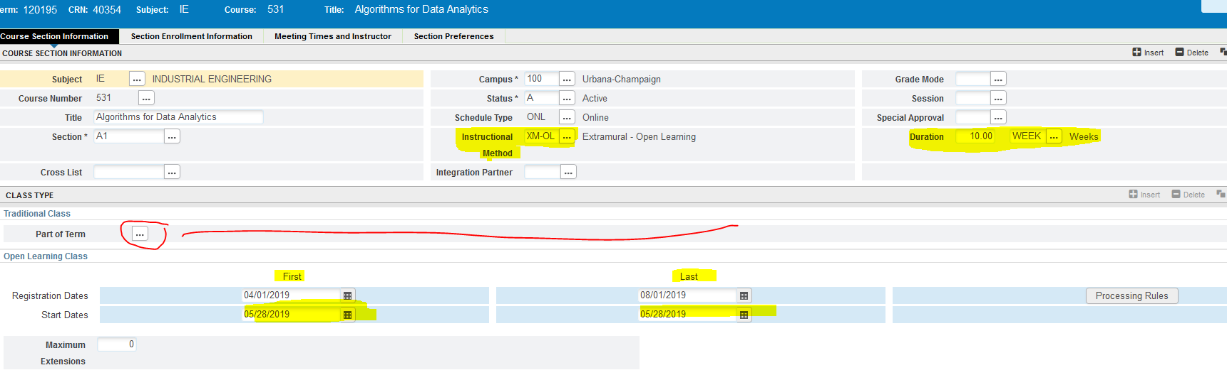
Other notes:
1). You may not repurpose an old CRN if it has never been XM-OL. You must create a new CRN.
2). If a CRN has been set-up as XM-OL in a past term, it may be only be repurposed for XM-OL sections. You may change the duration to reuse a CRN—but don’t forget to email us to enter the new rules to match the new duration.
3). When calculating duration, use calendar days. Use DAY as the duration from 2-28 days (2, 5, 6, 10, 14, 21, 28 are options); “WEEK” should be used for duration when 5 weeks and beyond.

4). Once you set up a section as XM-OL, email fms-courses@illinois.edu. We need to set up the refund rules and drop deadlines on the SSARULE form in Banner.
5). Students are not be able to use Self-Service to add sections that are XM-OL after the first day of class.
6). Drop deadlines and refund percentages for these sections can be found:
https://registrar.illinois.edu/wp-content/uploads/2019/01/Nonstandard_course_refund_guide.pdf
Contact Registration Services if you are unsure of the exact deadline date or how to interpret the guide.
7). If the final day of class is after the grade entry deadline, instructors will need to use the Grade Change System.

